 | MONTHLY COVERAGE PLAN
MONTH AUG., 2024 AREA SECRETARY: Josie Dela Cruz | WEEK: ⃝ 1 ⃝ 2 ⃝ 3 ⃝ 4 ⃝ 5 | COVERAGE DATE: AUG. 19-24, 2024 AREA: Mindoro whse.

MONDAY  DATE:8/19/24 |  | TUESDAY  DATE:8/20/24 |  | WEDNESDAY  DATE: 8/21/24 |  | THURSDAY  DATE: 8/22/24 |  | FRIDAY  DATE: 8/23/24 |  | SATURDAY  DATE:8/24/24
COVERAGE  PLAN | REMARKS | COVERAGE  PLAN | REMARKS | COVERAGE  PLAN | REMARKS | COVERAGE  PLAN | REMARKS | COVERAGE  PLAN | REMARKS | COVERAGE  PLAN | REMARKS
OTHER TRANSACTION |  | OTHER TRANSACTION |  | OTHER TRANSACTION | : | OTHER TRANSACTION |  | OTHER TRANSACTION |  | OTHER TRANSACTION

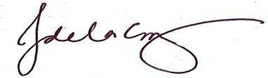

AREA SECRETARY COLLECTION OFFICER CREDIT AND COLLECTION MANAGER GENERAL MANAGER

