CERTIFICATE OF EMPLOYMENT
Company: Top Armada Cement Corporation

This is to certify that MS. RYZ MAE B. NEMENZO has been employed at Top Armada Cement Corporation from JUNE 3, 2020 up to SEPTEMBER 12, 2024 as a COLLECTION OFFICER.

Issued this September 12, 2024 at Ortigas Center, Pasig City.

PREPARED BY:

Redney M. Lom-oc
Executive Assistant of MD

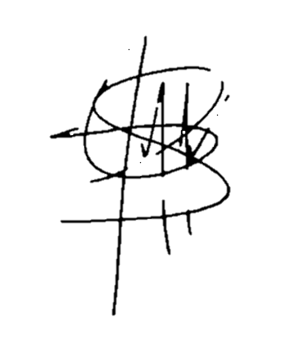
BY:

Maria Nikka Coleen H. Felizardo
Human Resources and Admin Manager

CERTIFICATE OF EMPLOYMENT
Company: Top Armada Cement Corporation

This is to certify that MS. GLENDA C. CARMONA has been employed at Top Armada Cement Corporation from FEBRUARY 1, 2021 up to SEPTEMBER 12, 2024 as a WAREHOUSE SUPERVISOR

Issued this September 12, 2024 at Ortigas Center, Pasig City.

PREPARED BY:

Redney M. Lom-oc
Executive Assistant of MD

BY:

Maria Nikka Coleen H. Felizardo
Human Resources and Admin Manager

